Reaction Rates
Reaction rate can be measured in 2 ways:
- By measuring the rate of disappearance of products.
- By measuring the rate of appearance of products.

According to collision theory, in order for a reaction to occur:
- Reactant particles must collide.
- Reactant particles must collide with the activation energy.
- Reactant particles must collide with correct orientation.

Activation energy: The minimum energy required to reach the transition state in a reaction.
Transition state (activation complex): A highly unstable arrangement in a reaction where bond-breaking and bond-forming is occurring; a momentary arrangement which has the highest enthalpy for the reaction.

- As bond strength increases, activation energy increases.
- As bond number increases, activation energy increases.
- As activation energy increases, the rate of reaction decreases.

Factors that affect reaction rate:
- Temperature:
Increasing temperature increases the average kinetic energy of the particles, increasing the proportion of particles that have sufficient kinetic energy to meet the activation energy required for a successful collision, hence increasing the reaction rate.
Increasing temperature increases the average kinetic energy of the particles, causing them to move faster and in doing so increase the rate of collisions that occur, hence increasing the reaction rate.
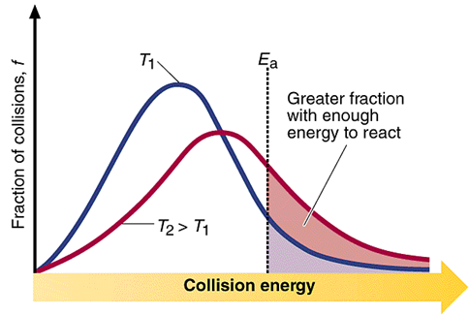
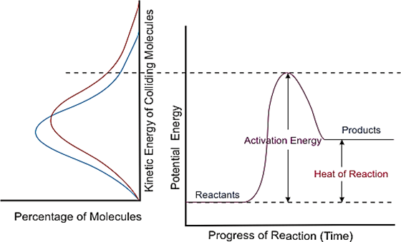
- Concentration:
Increasing the concentration of the reactants causes the distance between the particles to decrease. This increases the rate of collisions that occur, hence increasing the reaction rate.

- Pressure:
Increasing the pressure of the reactants causes the distance between the particles to decrease. This increases the rate of collisions that occur, hence increasing the reaction rate.

- State of subdivision:
Increasing the surface area of the reactants exposes more reactant particles to each other at one time, increasing the rate of collisions that occur, hence increasing the reaction rate.

- Catalysts:
Catalysts provide an alternate pathway with a lower activation energy. This means that a greater proportion of particles will have sufficient kinetic energy to meet the activation energy required for a successful collision, hence increasing the reaction rate.
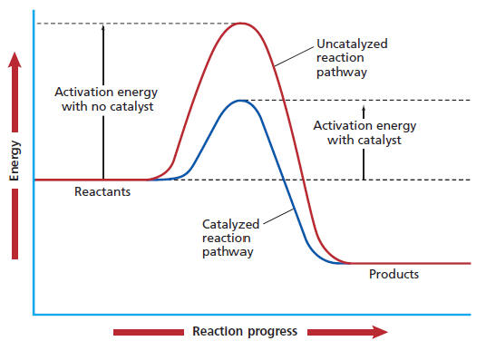
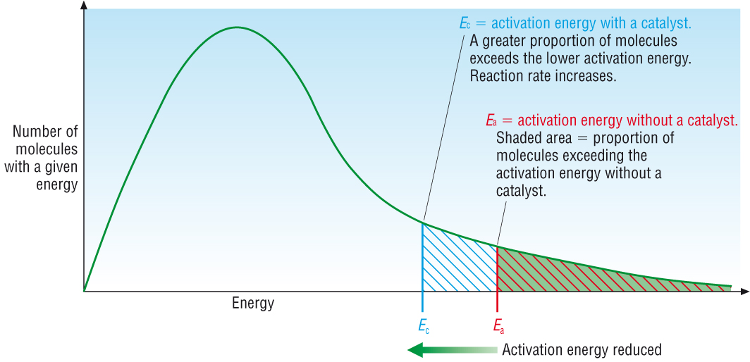
Enzyme: A protein that acts as a specific biological catalyst.
Substrate: The specific reagent molecule(s).
Enzyme specificity: The ability of an enzyme to catalyse a specific reaction.
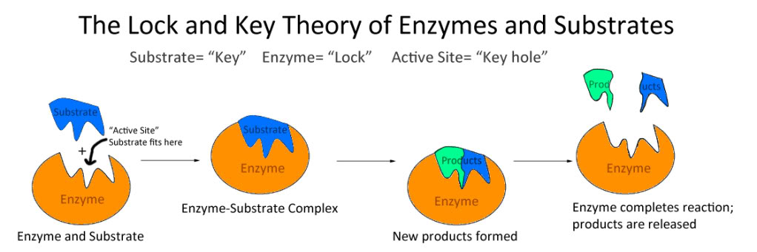
Nanocatalysts have a large surface area to volume ratio, maximising contact between the catalysts and reactants.
Benefits include:
- Large surface area to volume ratio.
- Large surface area to mass ratio.
- Requires much less of the expensive platinum.
- Can be manufactured on a large scale using a “green” method of production.

